**United States Department of Agriculture**

Food and Nutrition Service

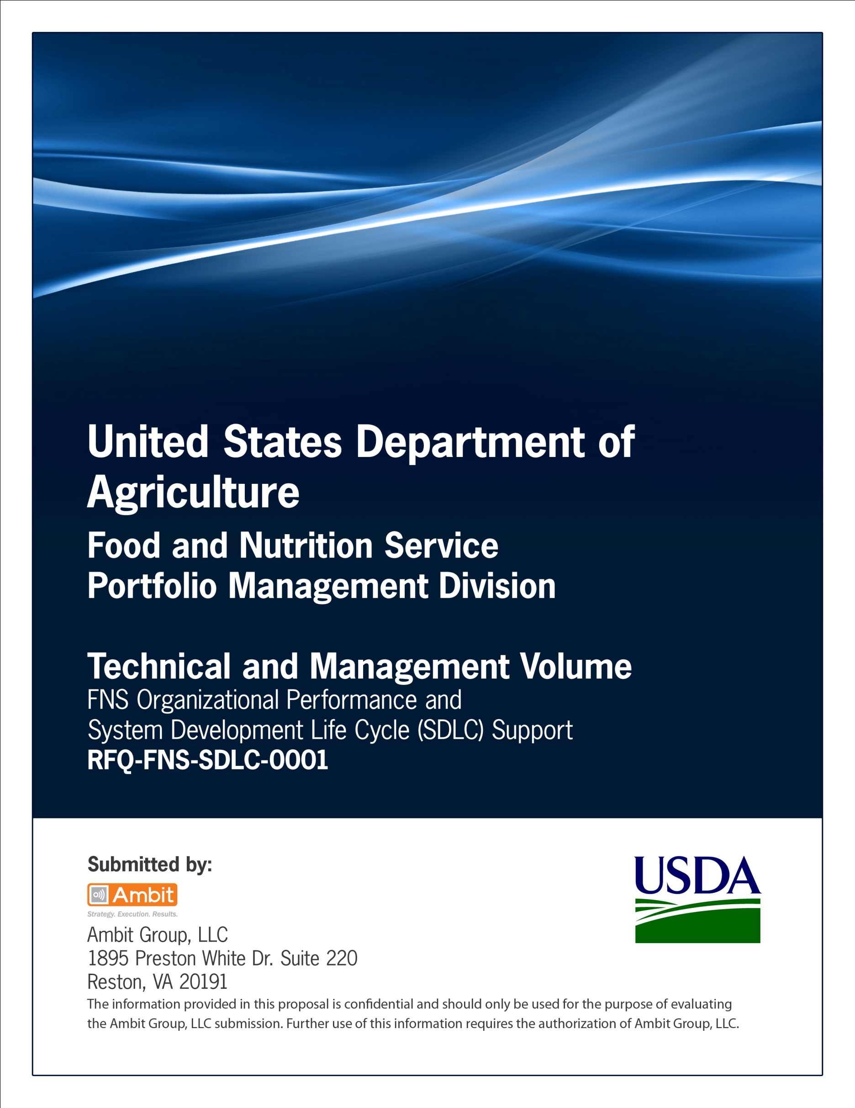

**FNS Office of Information Technology**

**Portfolio Management Division (PMD)**

**FNS Project Process Agreement Template**

**(PPA)**

***Medium-Sized Projects***

**for**

**[Project or System Name]**

**Version 1.1**

September 09, 2013

**Revision History**

|  |  |  |  |
| --- | --- | --- | --- |
| **Version** | **Date** | **Author** | **Change Description** |
| 1.0 | 03-12-2013 | IT Governance Branch (ITGB) | Created the document. |
| 1.1 | 09-09-2013 | IT Governance Branch (ITGB) | Re-formatted the document. |
| 1.2 |  |  |  |
| 1.3 |  |  |  |

**Contact Information**

|  |  |
| --- | --- |
| **Area of Concern** | **Contact Person** |
| IT Governance Lead | Kevin Russ |
| SDLC Coordinator | Syed Jaffery |
| ITIRB Coordinator | Sunny Dilawari |
| Portfolio Management Division Director, Chief Portfolio Officer | Jacqueline R. Butler |
| Program Management Branch Chief | Allison Willcox |

Contents

Glossary 4

1. Introduction 5

1.1. Purpose of the Project Process Agreement Document 5

2. Summary of Project Tailoring and Justification 5

3. Stage Gate Consolidation/Waiver Request 6

4. Deliverable Consolidation/Waiver Request 6

Appendix A: References 9

Approvals/Signatures 10

# Glossary

| **Acronym** | **Description** |
| --- | --- |
|  |  |
|  |  |
|  |  |
|  |  |
|  |  |
|  |  |
|  |  |
|  |  |

# Introduction

## Purpose of the Project Process Agreement Document

A Project Process Agreement (PPA) is used to authorize and document the justifications for using, not using, or combining specific Systems Development Life Cycle (SDLC) Stage Gate Reviews and the selection of specific deliverables applicable to the investment/project, including the expected level of detail to be provided. A PPA should be signed by the project manager and sponsor. Once approved by a governance committee this document authorizes the project to proceed according to agreed upon scope, time, costs, and quality including any SDLC related exceptions as outlined within this document.

General Information

|  |  |
| --- | --- |
| **Date Prepared** | mm/dd/yyyy |
| **Requested By** | Enter full name and title/role on project |
| **Email** | Enter email address |
| **Phone** | 000-000-000 |
| **Project Name** | Enter a name for the investment/project being requested |
| **Methodology** | Enter the methodology to be approved: Refer to “FNS SDLC Process and Methodology” for examples. |
| **Description** | Enter a detailed description of the investment/project |
| **Project Size** | Enter Project size - Small, Medium or Large |

# Summary of Project Tailoring and Justification

Use this section to briefly summarize the specific aspects of the SDLC lifecycle that are being tailored and explain why. Structure the lifecycle stages (phases or iterations) using the development methodology named in Section 1, number 6. Discuss the reasons for selecting the development methodology for this project. Projects will be approved to use the incremental, iterative or modular methodologies depending on the Program Manager’s request, the project team’s expertise, and management priorities of the Project Sponsor and OIT.

For projects using the Incremental Methodology, development is divided into independent mini-projects that are developed in parallel for systems with tight deadline requirements. Each mini-project progresses through every lifecycle stage featured in the PPA. The final project artifacts include a separate, complete set of deliverables for each mini-project designated in Section 3. Section 3 should be restructured to account for the additional sets of deliverables.

Projects that apply the Iterative Methodology combine multiple cycles of requirements, design, development, testing and/or deployment into one stage or iteration. Iterative projects produce one set of business and technical requirements and specifications for the whole project. The requirements and specification documents are continually updated to reflect the evolving requirements and deliverables discovered in ongoing stages. The requirements and specification documents must be kept current and should not be more than one sprint behind.

In addition to the evolving requirements and specification documents central to Iterative Methodologies, there may also be contractural requirements for additional deliverables and documentation in order to inform and collaborate with stakeholders, OIT management, the user community and vendors.

Projects that choose a traditional Modular Methodology conduct sequential phases in a serial manner that ensures one phase is complete before the next begins. The deliverables, development and documentation will be completed for one stage of Modular projects before the next stage of the lifecycle begins.

If the selected methodology is not covered by the previous options, the Program Manager designee should include a comprehensive description of the approach being proposed for approval. Explain the reasons for this choice, and discuss how the project will mitigate the additional risk associated with implementing a hybrid, non-standard or less common approach.

The project methodology will be reviewed and approved by OIT management so the PPA document should be submitted for approval well before development begins. Reference the “SDLC Guide” for a list of recommended deliverables per development stage.

# Stage Gate Consolidation/Waiver Request

| **SDLC Phases** | **Action** | **Justification** |
| --- | --- | --- |
|  | Valid actions include:   1. Use 2. Don’t Use 3. Combine | Enter justifications for using, not using, or combining specific SDLC Stage Gate Review and identify how to mitigate any associated risk |
| 1. Initiation* |  |  |
| 2. Requirements Analysis* |  |  |
| 3. Design* |  |  |
| 4. Development* |  |  |
| 5. Integration & Test* |  |  |
| 6. Implementation* |  |  |
| 7. Operations & Maintenance* |  |  |
| 8. Disposition* |  |  |

* All stage gates are required; but may be waived, combined or delegated based on IT Governance Branch approvals.

# Deliverable Consolidation/Waiver Request

| **SDLC Phases/Deliverables** | **Action** | **Justification** |
| --- | --- | --- |
|  | Valid actions include:   1. Use 2. Don’t Use 3. Combine | Enter justifications for using, not using, or combining specific SDLC deliverables and identify how to mitigate any associated risk  [Double asterisks** deliverables are optional for given stage. All others are required for small-sized projects] |
| **Initiation** |  |  |
| Acquisition Plan/Strategy |  |  |
| Acquisition Approval Request |  |  |
| Business Case FNS755 |  |  |
| Project Schedule |  |  |
| Business Case FNS758 |  |  |
| Cost Benefit Analysis |  |  |
| Integrated Project Team Charter** |  |  |
| Privacy Impact Analysis (PIA)** |  |  |
| Privacy Threshold Analysis (PTA)** |  |  |
| Project Management Plan** |  |  |
| Project Process Agreement (PPA) ** |  |  |
| **Requirements Analysis** |  |  |
| Concept of Operations |  |  |
| Electronic Information System (EIS) Questionnaire for Records Management Scheduling |  |  |
| Integrated Project Team Charter |  |  |
| Project Management Plan (PMP) |  |  |
| Privacy Impact Analysis (PIA) |  |  |
| Privacy Threshold Analysis (PTA) |  |  |
| Requirements Traceability Matrix |  |  |
| Project Process Agreement (PPA) |  |  |
| Systems of Records Notice (SORN) |  |  |
| System Requirements Specification (SRS) |  |  |
| FIPS 199 |  |  |
| **Design** |  |  |
| Configuration Management Plan |  |  |
| Domain Name Request |  |  |
| Procurement Documents (such as  Statement of Work (SOW)  Performance Work Statement (PWS)  Statement of Objectives (SOO) |  |  |
| Security Contingency Plan |  |  |
| System Design Document |  |  |
| Security Business Impact Assessment |  |  |
| Disaster Recovery Plan |  |  |
| **Development** |  |  |
| Test Plan |  |  |

|  |  |  |
| --- | --- | --- |
| **Integration & Test** |  |  |

|  |  |  |
| --- | --- | --- |
| App Scan Results |  |  |
| Operations/Maintenance Manual |  |  |
| Security Assessment Plan (Security Test & Evaluation Plan) (see ISO) |  |  |
| Section 508 VPAT and/or Certification |  |  |
| Security Assessment Plan (Security Test & Evaluation Plan) |  |  |
| System Security Plan (see ISO) |  |  |
| Test Results |  |  |
| Training Manual |  |  |
| Transition Plan |  |  |
| User Acceptance Testing (UAT) Signoff |  |  |
| User Manual |  |  |
| **Implementation** |  |  |
| Authority to Operate/Concurrency Review |  |  |
| Compliance Certification |  |  |
| Operational Readiness |  |  |
| Installation Document |  |  |
| Lifecycle Cost Estimate |  |  |
| Performance Measures |  |  |
| Project Closeout |  |  |
| Source Code |  |  |

|  |  |  |
| --- | --- | --- |
| **Operations & Maintenance** |  |  |

|  |  |  |
| --- | --- | --- |
| Annual Updates Required:   * Systems Security Plan * Contingency Plan * Disaster Recovery Plan * System Risk Management Plan * Lifecycle Cost |  |  |
| Authority to Operate (Every 3 Years) |  |  |
| Operational Analysis |  |  |
| Systems Post Implementation Review |  |  |
| **Disposition** |  |  |
| System Disposition Checklist |  |  |
| System Disposition Plan |  |  |
| Post Termination Review Report |  |  |

**IT Governance Approval**

__________________________________ __________________________

SDLC Coordinator Date

IT Governance Reviewer/Approver

Signature: Date:

Print Name:

Title:

# Approvals/Signatures

The undersigned acknowledge that they have reviewed the [name of document] document and agree with the information presented within this document. Changes to this document will be coordinated with, and approved by, the undersigned, or their designated representatives.

Signature: Date:

Print Name:

Title:

Role: [Project or System Name] Project Manager

Signature: Date:

Print Name:

Title:

Role: [Project or System Name] Business Owner

Signature: Date:

Print Name:

Title:

Role: Organization’s Approving Authority